Evan Wilson

CST-235

September 11th, 2018

Instructor: Dr. Toure

Short Assignment 5

GitHub Repo: https://github.com/ewilson87/CST235_ewilson Folder: ShortAssignment5

For this assignment, I created four initialization parameters in the web.xml file using the following tag style:

<init-param>

<param-name>firstName</param-name>

<param-value>Evan</param-value>

</init-param>

This was done to simulate parameters in a hypothetical application. In real world use, the actual values and names of the parameters would likely be different. Next, I created a very basic JSF page that lets the user know upon clicking the button, it will display every initialization parameter of the associated web.xml file. This button calls the doPost() method of the ShortAssignment5Servlet class. Within the servlet is where the logic of parsing the web.xml file comes in and prints all the init params to the user in basic text/html format.

List of files/classes/methods:

ShortAssignment5Servlet.Java class:

doPost() method //other default generated methods are present as well, but not used.

web.xml:

contains all the configurations for the application and the init params the servlet reads

index.xhtml:

Basic JSF page with button to interact with the servlet

Screenshot of the welcome page when launching the application:

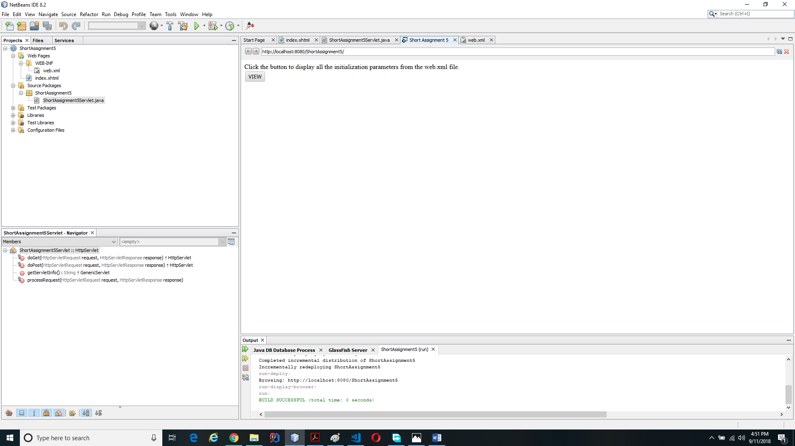

Screenshot after clicking the button, once the doPost() method is called and parsed the web.xml file.